HANDS-ON 2 [Beginner]

Commands Used
- ng new student-course-portal
- cd student-course-portal
- ng generate component components/header
- ng generate component pages/home
- ng generate component pages/course-list
- ng generate component pages/student-profile
- ng generate component components/course-card
- ng serve

Project Structure
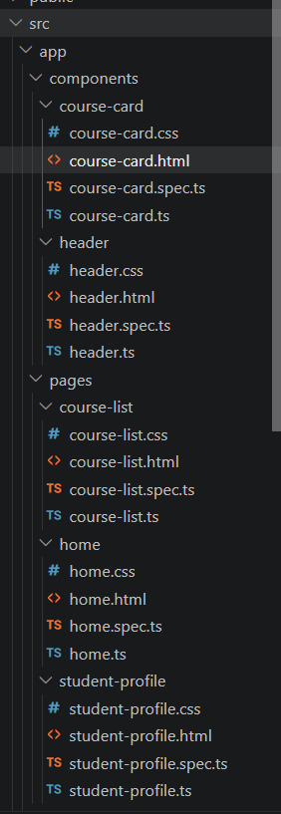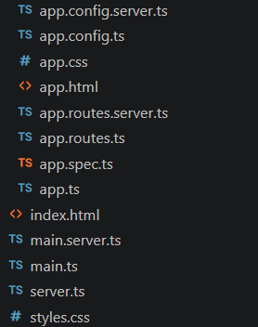

Key Code Files

course-list.ts
import { Component } from '@angular/core';
import { CommonModule } from '@angular/common';
import { CourseCard } from '../../components/course-card/course-card';

@Component({
selector: 'app-course-list',
standalone: true,
imports: [CommonModule, CourseCard],
templateUrl: './course-list.html',
styleUrl: './course-list.css'
})
export class CourseList {

courses = [
{
id: 1,
name: 'Angular',
code: 'ANG101',
credits: 4
},
{
id: 2,
name: 'Java',
code: 'JAVA201',
credits: 3
},
{
id: 3,
name: 'Python',
code: 'PY301',
credits: 2
},
{
id: 4,
name: 'Data Structures',
code: 'DS401',
credits: 4
},
{
id: 5,
name: 'Machine Learning',
code: 'ML501',
credits: 5
}
];
selectedCourseId: number = 0;
onEnroll(courseId: number): void {
this.selectedCourseId = courseId;
console.log('Course ID:', courseId);
console.log('Selected Course ID:', this.selectedCourseId);
}
}

course-list.html
Displays course cards and listens to enrollRequested event.
<h2>Available Courses</h2>

<app-course-card
*ngFor="let course of courses"
[course]="course"
(enrollRequested)="onEnroll($event)">
</app-course-card>

<hr>

<p *ngIf="selectedCourseId > 0">
<strong>Selected Course ID:</strong>
{{ selectedCourseId }}
</p>

course-card.ts
Uses @Input(), @Output(), EventEmitter and ngOnChanges().
import {
Component,
Input,
Output,
EventEmitter,
OnChanges,
SimpleChanges
} from '@angular/core';
@Component({
selector: 'app-course-card',
imports: [],
templateUrl: './course-card.html',
styleUrl: './course-card.css'
})
export class CourseCard implements OnChanges {
@Input()
course: any;

@Output()
enrollRequested = new EventEmitter<number>();
ngOnChanges(changes: SimpleChanges): void {
console.log('Previous Value:', changes['course']?.previousValue);
console.log('Current Value:', changes['course']?.currentValue);
}

enroll() {
this.enrollRequested.emit(this.course.id);
}
}

course-card.html
Displays course details and Enroll button.
<div class="course-card">
<h3>{{ course.name }}</h3>
<p><strong>Code:</strong> {{ course.code }}</p>
<p><strong>Credits:</strong> {{ course.credits }}</p>
<button (click)="enroll()">
Enroll
</button>
</div>

Output
